

**Course code : “207”**

**Course Name : Software Engineering Theory**

Project Name : **Fitness club**

**Final Project**

Full Name ID

* Mohamed Ahmed Ibrahim 203110
* Adham Mohamed Mohamed 203018
* Mustafa Ashraf Samir 203141

Nov 2020

Contents

Team 1

Document Purpose and Audience 2

Introduction 3

Software Purpose 3

Software Scope 3

Definitions, acronyms, and abbreviations 3

Requirements 4

Functional Requirements 4

Non Functional Requirements 4

System Models 5

Use Case Model 5

Use Case Tables 5

Ownership Report 6

Policy Regarding Plagiarism: 6

# Introduction

## Software Purpose

* **To Automate Gym & Fitness admission Process.**

## Software Scope

* **selecting a trainer is difficult. Sometimes it is difficult to get a desired slot timing**
* **Being healthy is the first thing to be kept in mind because most of the time our attitude depends on how we feel**

## Definitions, acronyms, and abbreviations

* **Functional : system or its component. It describes the functions a software must perform.**
* **Non-Functional : the quality attribute of a software system. They represent a set of standards used to judge the specific operation of a system.**

# Requirements

## Functional Requirements

* **Login.**
* **Registration**
* **Scheduling classes**
* **Managing packages**
* **Mange member details**
* **Change password**
* **Booking workout**
* **View their profiles and list of trainers.**
* **View the package**
* **Set the member Profile.**
* **Logout**

## Non Functional Requirements

* **User friendly interface**
* **Scalability**
* **Performance**
* **Security**
* **Privacy**
* **Mobile app for android and IOS.**
* **Web page**
* **Usability**
* **flexible**

|  |  |
| --- | --- |
| **Non-Functional Requirements** | **Details** |
| **Performance** | * **Attendance operation will be done within 20 seconds and shorten the data transmission time** |
| **Scalability** | * **System should be able to support up to 1000 Member** |
| **Security** | * **System should be able to Secure the users information** |
| variety | * **Software should be supported by several platforms** |
| **Backup** | * **Backup user’s information could be large as it’s saving a copy of all data considered worth saving** |

# 

# System Models

# Use Case Model

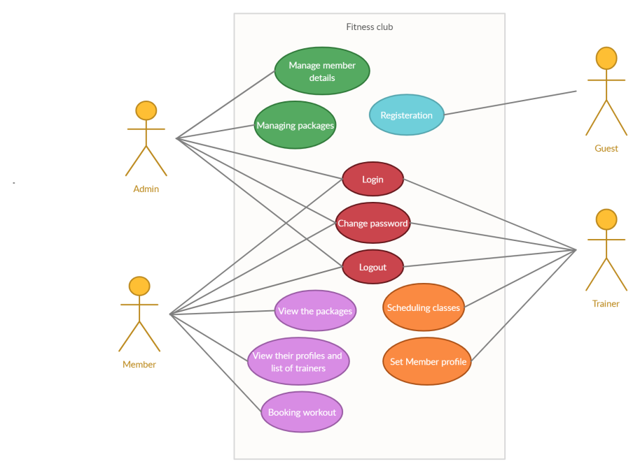

## Use Case Tables

|  |  |  |
| --- | --- | --- |
| Use Case ID: | 1 | |
| Use Case Name: | Login | |
| Actors: | Admin, Member and Trainer. | |
| Pre-conditions: | none | |
| Post-conditions: | Access the system | |
| Flow of events: | **User Action** | **System Action** |
| 1- enters the login information |  |
|  | 2- the system checks the validity of the login details if valid the system will all function |
|
|
|
| Exceptions: | **User Action** | **System Action** |
| 1- enters the login information | 1- invalid login  2- Invalid Password  3- NO internet connection |
|
| Includes: | 5 times a day | |
| Notes and Issues: | Can’t login without internet connection | |

|  |  |  |
| --- | --- | --- |
| Use Case ID: | 2 | |
| Use Case Name: | Manage The packages | |
| Actors: | Admin. | |
| Pre-conditions: | Login | |
| Post-conditions: | Add ,remove and edit the packages with the admin dashboard | |
| Flow of events: | **User Action** | **System Action** |
| 1- enters the login credentials |  |
| 2- Manage the packages | 2- the system checks the validity of the login details if valid the system will all function |
| 3- add, remove and make discount | 3- Show list of the packages |
| 4- Save the edited package | 4- add : add new packages according to the package details  Remove : remove the old packages  Make discount : making sale on packages |
|  | 5- Edited packages saved in the database |
| Exceptions: | **User Action** | **System Action** |
| 1- enters the login information | 1- invalid login  2- Invalid Password  3- Failure in internet connection |
|
| Includes: | With admin privilege can edit and add or remove as long as he logged in | |
| Notes and Issues: | Can’t login without internet connection | |

|  |  |  |
| --- | --- | --- |
| Use Case ID: | 3 | |
| Use Case Name: | Manage the Member’s details | |
| Actors: | Admin | |
| Pre-conditions: | Login | |
| Post-conditions: | Edit the Member’s details | |
| Flow of events: | **User Action** | **System Action** |
| 1- enters the login information |  |
| 2- show the admin specific details of a member | 2- the system checks the validity of the login details if valid the system will all function |
| 3- edit the details | 3- Show the member’s old details |
| 4- save the new details | 4- Save the new details in the database and remove the old ones |
|
|
|
| Exceptions: | **User Action** | **System Action** |
| 1- enters the login information | 1- invalid login  2- Invalid Password  3- Failure in internet connection |
|
| Includes: | With admin privilege can manage the members details as long as he logged in | |
| Notes and Issues: | Can’t login without internet connection  Can’t edit the same details twice a day | |

|  |  |  |
| --- | --- | --- |
| Use Case ID: | 4 | |
| Use Case Name: | Registration | |
| Actors: | Guest | |
| Pre-conditions: | register | |
| Post-conditions: | Enter account information | |
| Flow of events: | **User Action** | **System Action** |
| 1. enters account information :   Email address  Username  Password |  |
|  | 2- the system checks the validity of the account information if valid the system will save the account information in database |
|  |  |
|
|
|
| Exceptions: | **User Action** | **System Action** |
| 1- enters the account | 1- invalid email address  2- Invalid username  3- Failure in internet connection |
|
| Includes: | With registered account the guest can choose a package from package list and can book a workout | |
| Notes and Issues: | Can’t register without internet connection | |

|  |  |  |
| --- | --- | --- |
| Use Case ID: | 5 | |
| Use Case Name: | View their profiles | |
| Actors: | Members | |
| Pre-conditions: | Login | |
| Post-conditions: | view their profiles and a list of trainers | |
| Flow of events: | **User Action** | **System Action** |
| 1- enters the login credentials |  |
| 2- view the profile | 2- the system checks the validity of the login details if valid the system will all function |
| 3- choose the desired trainer from a list | 3- system open the profile page |
|  | 4- the system sends a email to the trainer to inform him about the new registered member to his class |
|
|
|
| Exceptions: | **User Action** | **System Action** |
| 1- enters the login credentials | 1- invalid login  2- Invalid Password  3- Failure in internet connection |
|
| Includes: | Can view their profile as long as they logged in | |
| Notes and Issues: | Can’t login without internet connection | |

|  |  |  |
| --- | --- | --- |
| Use Case ID: | 6 | |
| Use Case Name: | View the packages | |
| Actors: | Members | |
| Pre-conditions: | Login | |
| Post-conditions: | view the packages details and the payment information | |
| Flow of events: | **User Action** | **System Action** |
| 1- enters the login credentials |  |
| 2- view their package | 2- the system checks the validity of the login details if valid the system will all function |
| 3- view the payment details | 3- system open the packages page |
|  | 4- the system shows up the payment details |
|
|
|
| Exceptions: | **User Action** | **System Action** |
| 1- enters the login credentials | 1- invalid login  2- Invalid Password  3- Failure in internet connection |
|
| Includes: | Can view their packages and the payment details as long as they are logged in | |
| Notes and Issues: | Can’t login without internet connection  Can’t see the whole payment details in case of security | |

|  |  |  |
| --- | --- | --- |
| Use Case ID: | 7 | |
| Use Case Name: | Set member profile | |
| Actors: | Trainer | |
| Pre-conditions: | Login | |
| Post-conditions: | Setting up their profiles | |
| Flow of events: | **User Action** | **System Action** |
| 1- enters the login credentials |  |
| 2- Profile | 2- the system checks the validity of the login details if valid the system will all function |
| 3- Set up his profile | 3- system open the trainer Profile page |
|  | 4- the system saves the trainer details |
|
|
|
| Exceptions: | **User Action** | **System Action** |
| 1- enters the login credentials | 1- invalid login  2- Invalid Password  3- Failure in internet connection |
|
| Includes: | Set up the profile once a month | |
| Notes and Issues: | Can’t login without internet connection | |

|  |  |  |
| --- | --- | --- |
| Use Case ID: | 8 | |
| Use Case Name: | Logout | |
| Actors: | Admin, Member and Trainer | |
| Pre-conditions: | Login | |
| Post-conditions: | none | |
| Flow of events: | **User Action** | **System Action** |
| 1- enters the login credentials |  |
| 2- explore the system | 2- the system checks the validity of the login details if valid the system will all function |
| 3- logout | 3- exploring the system without any issues |
|  | 4- the system saves the session and closes |
|
|
|
| Exceptions: | **User Action** | **System Action** |
| 1- enters the login information | 1- invalid login  2- Invalid Password  3- Failure in internet connection |
|
| Includes: | Logout daily | |
| Notes and Issues: | Can’t login without internet connection can’t logout once logged in directly | |

|  |  |  |
| --- | --- | --- |
| Use Case ID: | 9 | |
| Use Case Name: | Booking workout | |
| Actors: | Member | |
| Pre-conditions: | Login | |
| Post-conditions: | Booking workout | |
| Flow of events: | **User Action** | **System Action** |
| 1- enters the login information |  |
| 2- explore the system | 2- the system checks the validity of the booking details if valid the system will all function |
| 3- logout | 3- system open workout page |
|  | The system records the reservation |
|
|
|
| Exceptions: | **User Action** | **System Action** |
| 1- enters the login information | 1- invalid login  2- Invalid Password  3- Failure in internet connection |
|
| Includes: | can check availability of trainer | |
| Notes and Issues: | Can’t booking without internet connection  can’t book if the trainer is busy | |